Meta Ads Campaign Plan for Astrotalk
Astrotalk - Tailored messages campaign - 25 Dec 2025
Brand: Astrotalk
Campaign Goal: Receive messages (chat inquiries)
Platform: Meta Ads (Facebook & Instagram)
Budget: ₹15,000
Duration: 15 Days
1. Competitor Research (3 Competitors)
- Astroyogi
- ClickAstro
- GaneshaSpeaks
2. Unique Selling Points (USPs) of Astrotalk
- Instant Chat with Verified Astrologers
- Affordable Per-Minute Pricing
- Wide Range of Astrology Services
- Available in Multiple Indian Languages
- Trusted Platform with Millions of Users
3. Campaign Setup
a) Selected Objective
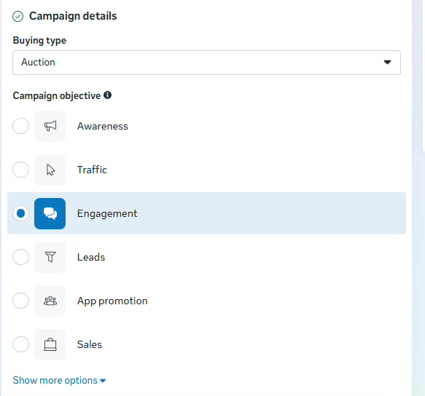
b) Budget Setup
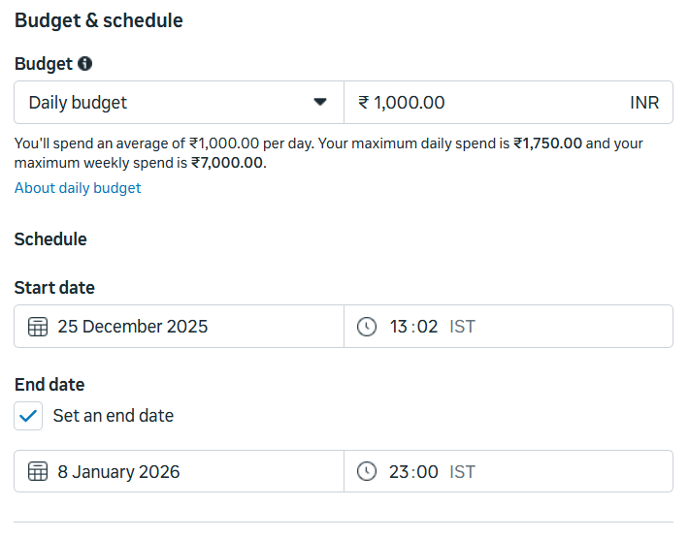
c) Audience Targeting
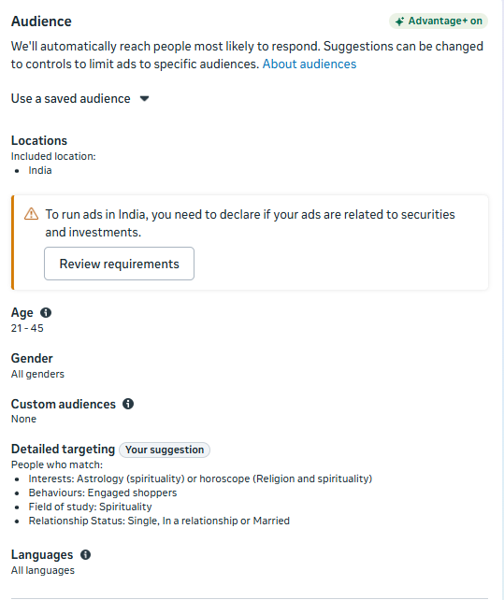
d) Placement Selection
Advantage+ Placements (Automatic)
e) Ad Preview (Creative Copy)
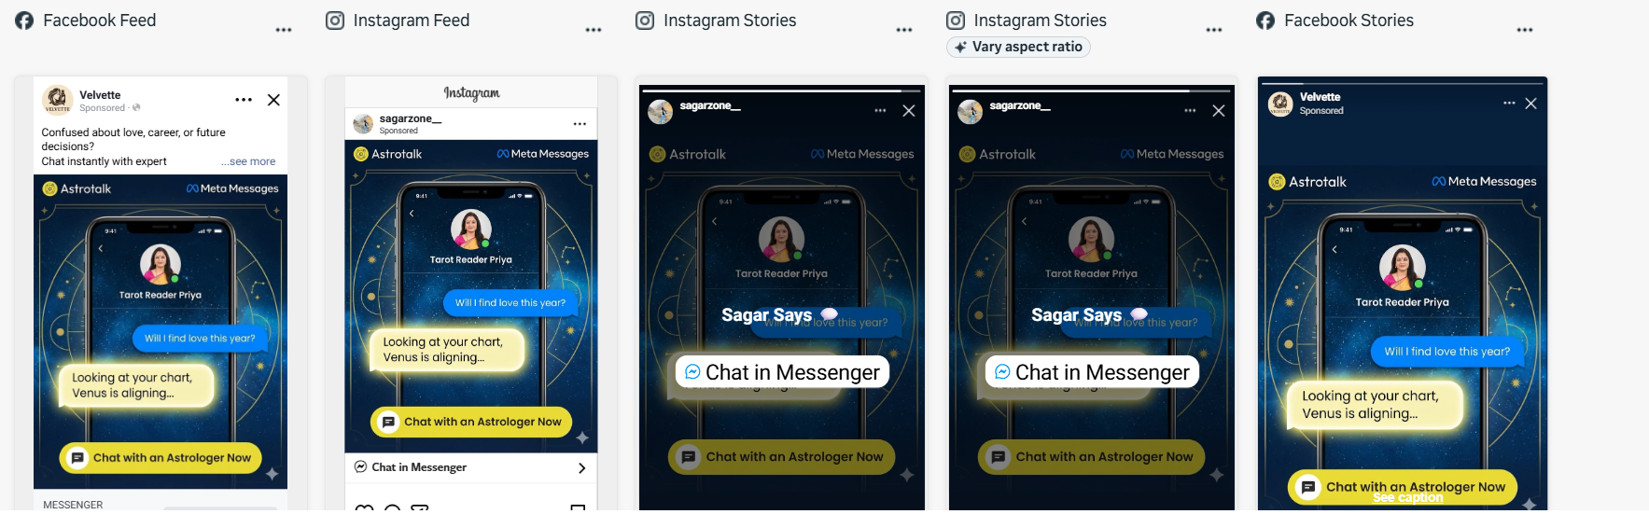
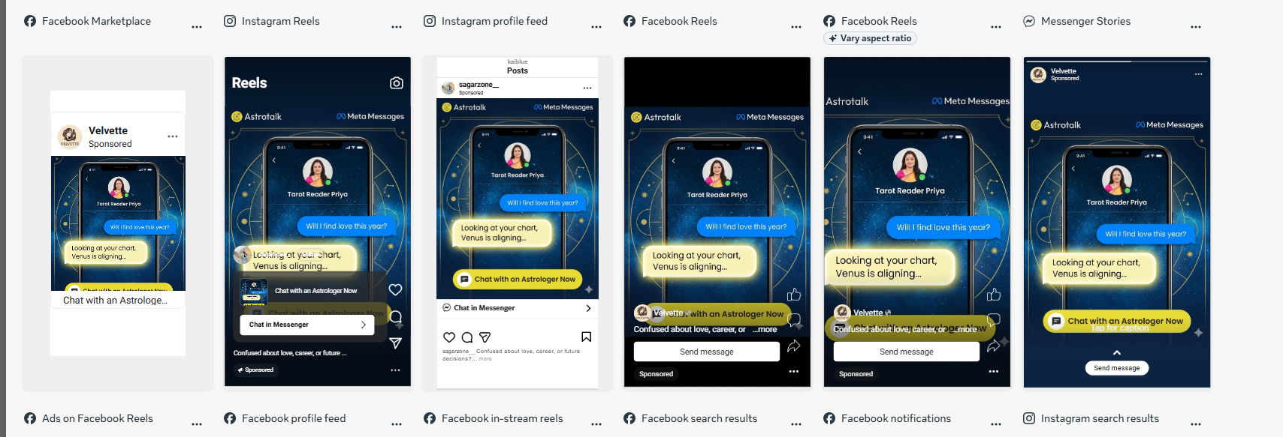
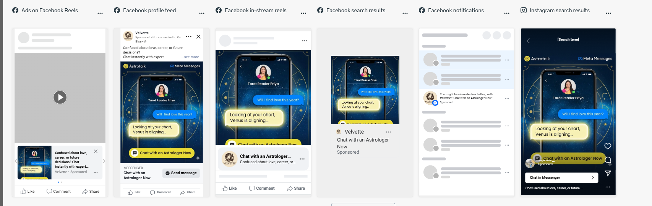
f) Chat Setup Preview
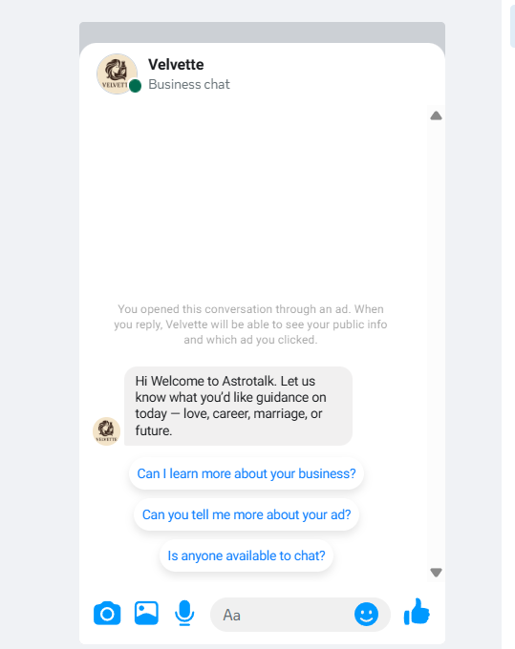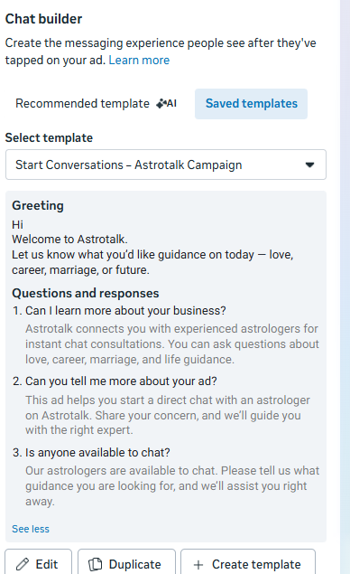
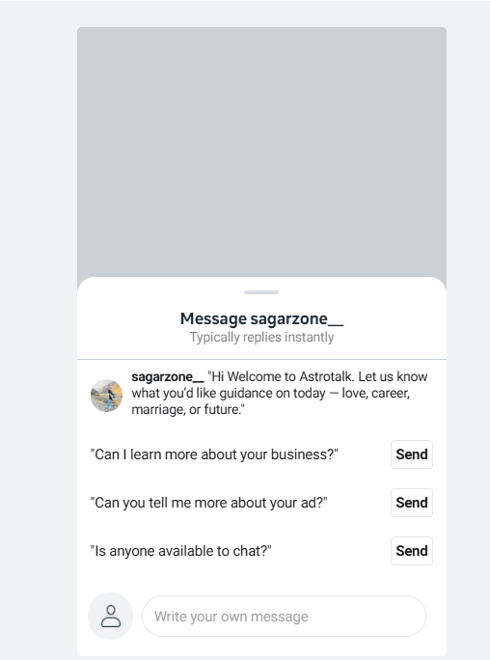

g) Estimated Campaign Results
